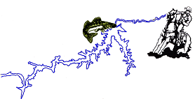

Donated by The Wolf Point Chapter of MT Walleyes Unlimited at participating Ft. Peck Championship Series events
***Must be 10 inches or less and does not count towards five fish limit – Teams can only measure 1 small fish per day.

