FWP Preliminary proposals for 2025-2026 fishing regulations available for review
By Dale Gilbert

HELENA – If you’re interested in providing input on how Montana Fish, Wildlife & Parks is crafting fishing regulations for the next two years, now is your chance. FWP is taking public comment and asking for ideas on initial proposals for the 2025-2026 Fishing Regulations.
The initial 64 proposals are online now and available for review and comment. Just go to fwp.mt.gov/aboutfwp/public-comment-opportunities/fishing-regulations.
The comment deadline is April 26, 2024.

Some highlights and my two cents worth on some that may be of interest to you:

Proposal 2 to allow filleting of fish on the water unless there are size or slot limits…requiring skin to be left on but allowing for disposal of the carcasses, etc. away from boat ramps and campgrounds.

I’d generally support this, yet have some reservations:

- How will this allow valid creel census data to be collected?

- Once off the water, either at a fillet station if one exists or at my camper, I’d like to remove the skin and not be required to leave the skin on to transport my fish home.

Proposal 46 restrict anglers to only 1 line with 2 hooks on the Maria’s River.

I’m opposed to this change. I see no reason to not allow 2 attended lines with 2 hooks just like on the reservoirs, and other major rivers….in fact the standard should be 2 lines with 2 hooks district wide…..this would simplify regulation. Daily and possession limits already protect the fish population, why limit an angler to only one rod, when obviously in most areas I fish, it is the standard.

*** Proposal 47 to change limits on Missouri River from Toston Dam to Hwy 287 bridge in Townsend. Opposed!

FWP data does not support or justify changing the limits in the river that will conflict with and undermine the efforts, strategies and actions to improve the CF fishery.

The current regulation of 10 fish, not more than 1 - 15” or > was set up to specifically encourage anglers to harvest numbers of smaller fish to keep relative abundance numbers within goals, and allow some of the 15” fish a chance to live another year and increase average size and numbers of “quality” (15” & >) fish to improve the overall CF fishery.

The UMRRMP page 16 says FWP is required for “Both River Sections:
• Consider impacts with adjacent reservoir management goals, strategies, and regulations when implementing river management actions.”

This proposal directly conflicts with the adjacent reservoir goals, objectives and regulations.

FWP claims this change won’t impact the reservoir, that the population migrating into the river is so small, that harvest in the river won’t significantly impact in the reservoir fishery…..however facts from the prior telemetry study in 2015 and the river tagged walleye tag returns both show relatively high percentages of them moving back into the reservoir and being accessible to reservoir anglers. In fact, 30.8% of the telemetry fish tracking logs showed movement beginning in Mid July into September back into the reservoir. By late fall, only 6 still showed being in the river the last time they were located, 5 of those at river mile 2.4 below the bridge and only 1 at river mile 19 on 8/10/2015 the last time it was located.

In fact, 37.9% of the tag returns from the electrofishing river tagged fish from 2015-2023 were reported caught by anglers fishing in the reservoir. So for FWP to claim harvest in the river will not impact the reservoir is without data to support their statements. The data disproves their claim.

In addition then, the proposed changes removes the incentive for anglers to catch and keep the smaller (<15”) fish. They won’t be harvested and they will end up back in the reservoir adding to the already high numbers of smaller fish. This conflicts with the goals for the reservoir.

Allowing anglers to keep 5 times the number of quality (15” & >) walleye will suppress the numbers and reduce the probability of seeing some of them growing into older year classes, and trophy class fish. Those fish will not be available to the reservoir anglers. This conflicts with the goals to improve the quality fish in the reservoir, increasing the numbers of quality fish and the PSD.

Taking a step further, the stomach sampling and diet analysis was during the peak migration and the relatively short period of time (3-4 months) that these fish were in the river (5/4 – 8/27)….which is not during the brown trout spawn. FWP took stomach samples from 74 walleye, and documented only 44 had fish and that only 4.9% was salmonids….meaning at peak times over 95% of the diet was something other than salmonids. Now they claim 7% had trout from 52 samples? I still don’t understand why they don’t include the fish with nothing in their stomachs in their calculations. Regardless, considering the fish are not in the river the other 8-9 months of the year and not preying on the trout, nothing suggests the walleye migrating into the river have an adverse impact of any significance to the trout fishery in the river. So what justifies suppression of walleye in the river that conflicts with the reservoir goals?

Beyond that, when you look at the FWP data on trout catch per unit effort for both rainbows and brown trout per the UMRRMP they are at or above the management plan goals for 2023 and better than the averages for both.

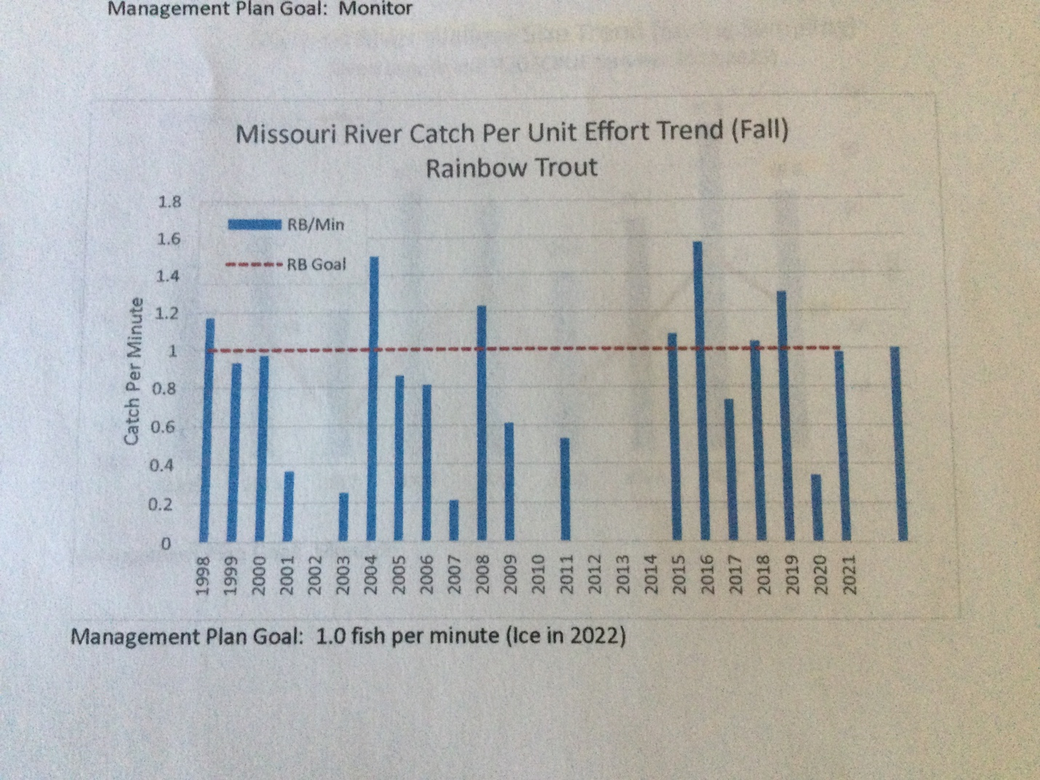
For rainbow, there were only 7 years since 1998, the trout numbers were better, and 4 of those were since 2015 when walleyes were present. In fact in 2016, with walleyes present, they showed the highest catch per unit effort of record going back to 1998. So what problem are they trying to fix? With the goals for trout being met, what justifies suppressing the walleye?

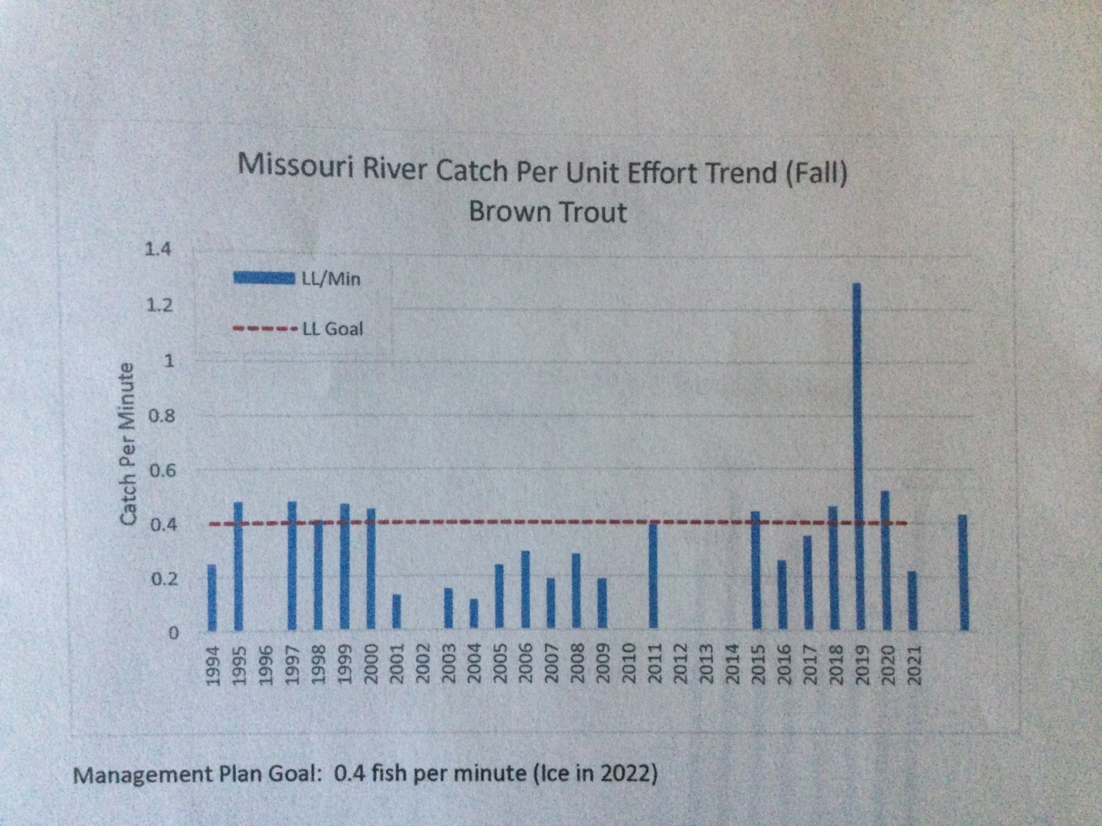
For brown trout, the numbers were better only 8 times since 1994 when the trout numbers were better and most were only marginally better, except for 3 of those that were from 2015 on when walleye were present. In 2019 the trout numbers were the best on record. So again, what is the problem?

It doesn’t appear from any of their data that the walleye population has been or is detrimental to the trout fishery in the river.

And then having a different limit above the Hwy 287 bridge will create an enforcement problem as people that access the river from the Silos or Cottonwood may run up and fish above the bridge and when coming off the water will be in an area where 5 fish any size is not legal. This does not simplify the regulations and will likely cause problems.

So what justifies taking an action that conflicts with the strategies, goals, and efforts for the reservoir? I can’t see it.

Especially when the goals for the trout in the river are already being met!

The proposed changes would absolutely impact the reservoir fishery in a negative way, contrary to FWP’s opinion, and contrary to the goals, strategies and regulations currently in place per the UMRRMP.

Proposal 48 Changing walleye limits from Holter Dam to Black Eagle Dam to 10 daily/ 20 possession. This would reduce the current 20 fish limit from Holter to Cascade.

I support the reduction, but still question the need for the excessively liberal 10 fish limit and wonder why it is not 5 like Holter and the statewide standard. Frankly, the increase back in 2010/11 for no limit, and the 20 fish limit currently in effect, have never been biologically or scientifically supported by data. The history of this fishery has shown in high water flows years it resulted in higher levels of fish flushing of fish into the system, creating small increases walleye numbers at times, but it has always seen subsequent significant declines in walleyes numbers in the subsequent years and yet has always shown outstanding trout numbers. For example, based on the 2023 electro-fishing reports on the two sections of Missouri river typically checked every year, there was a total of 12,340 trout captured vs. 74 walleye. The walleye make up .6%, less than 1% of the trout population. This is insignificant and barely measurable.

Over all the years, FWP has never documented any findings that the walleye in the Missouri River have been detrimental to the trout population so there is no justification for excessively liberal limits that have been put in place.

OTHER:

I have to wonder how allowing 6 set lines with up to 6 hooks can be prudent in open waters, especially those with restricted sauger limits or even 5 fish walleye limits? I know I’ve fished the Fred Robinson bridge on the Missouri river in the spring of the year where there were so many set lines in every good hole, I practically couldn’t fish, I don’t feel it is feasible to mange harvest limits with allowing so many set lines and hooks/ angler especially unattended and this should be revised.

Secondly, I’d like to see the standard 2 lines with 2 hooks per line set for the entire central and eastern districts for rivers, lakes, and reservoirs. For example, with Holter, Hauser, Canyon Ferry, and most all the reservoirs an angler can use 2 lines with 2 hooks, but fishing the Missouri River from Holter to Black Eagle can only use 1 line with 2 hooks….why? Possession limits already limit angler harvest, so why the difference in regulations.

Third, I’ve got to wonder in considering the reduction in the Lake Francis fall gill netting numbers and negative trend, if it doesn’t mean a reduction in daily limits, a slot, or other management actions need to be considered. The relative abundance of walleye in Frances has dropped each year for the past three years to 4.9/net…with only 4 years over the past 20 with lower numbers. The 4.9 is below the statewide management plan goal of 5-9/net and the third year of declining numbers.

Although, FWP doesn’t apparently have data to show what impact anglers are having with advanced knowledge, skill, abilities, equipment like forward facing sonar, and an information network like we never had years ago….the decreased numbers show things are changing and it may mean, regulation changes may need to be revised to provide some relief.

